
A 10

Sreenidhi Institute of Science & Technology
(An Autonomous Institution)
Code No: 101EC08

B. TECH. II – Year II – Semester Examinations, December, 2013 (Supplementary)
SIGNALS AND SYSTEMS ( ECM )

Time: 3 Hours Max. Marks : 70

Note : No additional answer sheets will be provided.

Part-A (Objective Type)
Max.Marks:20

Answer all QUESTIONS.

1. What is orthogonal signal space?
2. What is Fourier spectrum?
3. When are the Z-transform and discrete - time Fourier transforms same?
4. What are the necessary and sufficient conditions for the existence of Laplace Transform.
5. What is Paley - Wiener Criterion?
6. What is the difference between convolution and correlation?
7. Define Normalized energy.
8. Determine the Nyquist sampling rate and Nyquist sampling internal of the singla given below. x(t) = sin c [100πt].
9. Determine the z-transform and ROC of the following finite duration signal.
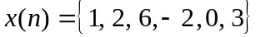

10. State the following properties of Z-transform.
a) Differentiation property.
b) Convolution property.
Part – B
Max. Marks: 50

ANSWER ANY FIVE QUESTIONS. EACH QUESTION CARRIES 10 MARKS.

1. a) Derive an expression for Mean square error. [5+5]
b) Prove that the complex exponential signals are orthogonal functions.
2. a) Find trigonometric Fourier series for square wave shown below. [6+4]
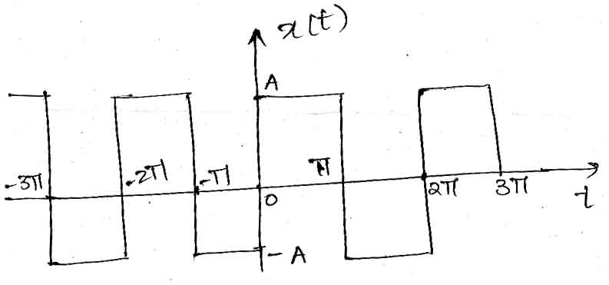

b) State and prove frequency shifting property of Fourier series.
3. Find the Fourier transform of the following functions. [5+5]
i) Signum function ii) Unit step function
4. a) Determine the Laplace transform of the following signals [5+5]
i) f(t) = e^{-at} cos (ω₀t). u(t) ii) x(t) = u(t+T) - u(t-T).
b) Using convolution theorem, find inverse Laplace transfrom of
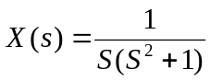
5. a) Let the system function of LTI system be 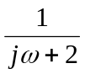. What is the output of the system for an input (0.8)^{t}. [5+5]
b) Derive the relation between bandwidth and rise time.
6. a) Find the cross - correlation of the signal x(t) of y(t) as shown below. [5+5]
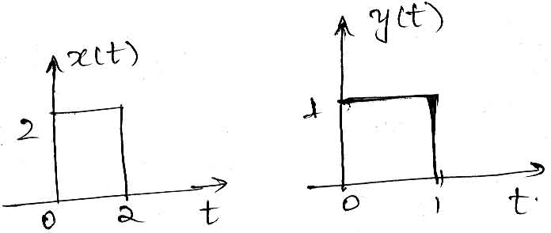
b) Find auto correction, power RMS value and sketch the PSD for the signal.
x(t) = (A+sin 100t). cos 200t
7. a) State and prove sampling theorem for band limited signals. [6+4]
b) Distinguish between Natural and flat top sampling.

8. a) Determine the inverse Z-transform using power series method [6+4]
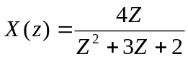; ROC |Z| > 2
b) Distinguish between Laplace transform, Z-transform, Fourier transform.
-- 00 -- 00 --

